1：Over all
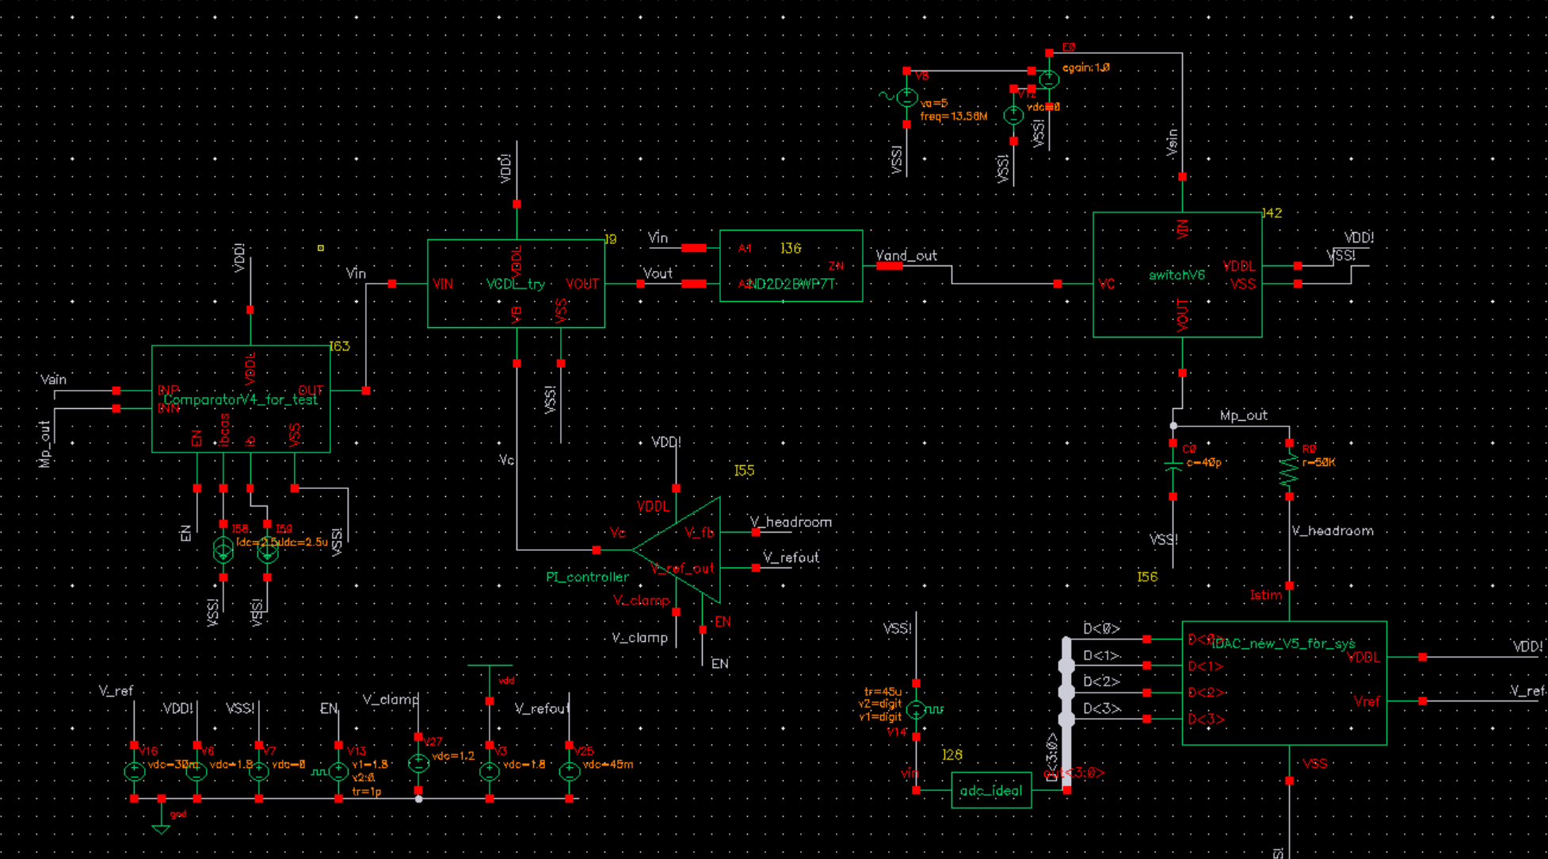
The whole system is kind of finished(kind of)
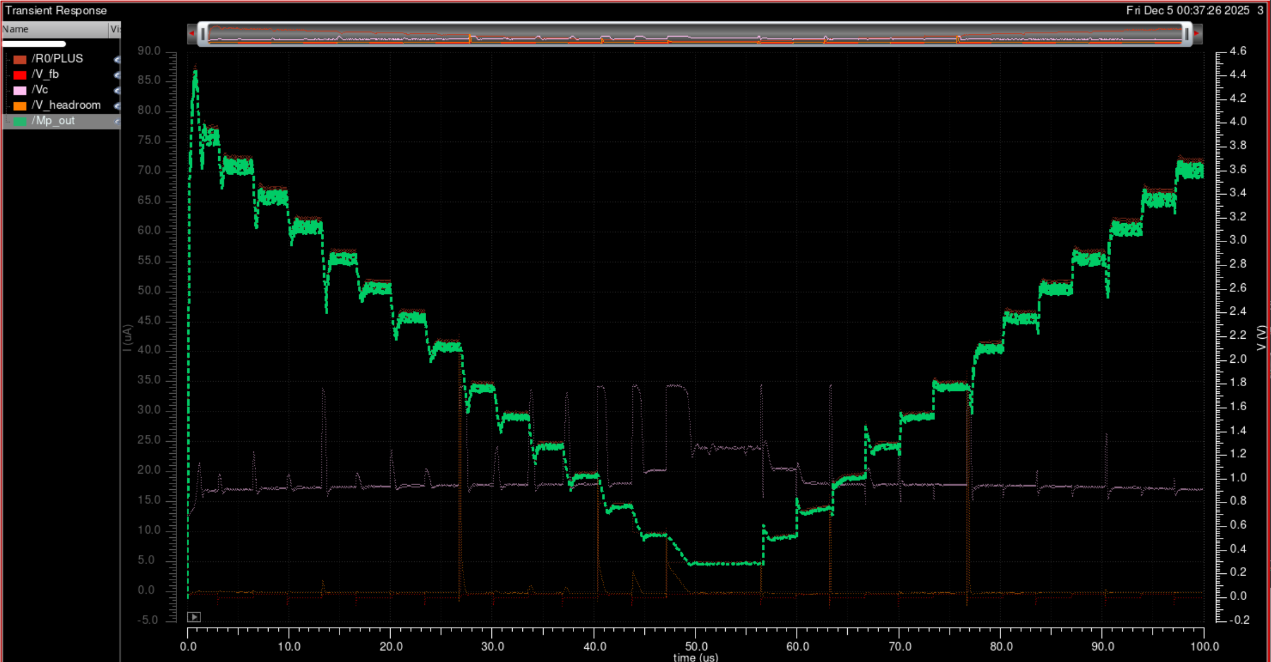
Current is accurate, Vheadroom can control at around 43mV. The headroom can be lower to save a little bit more power, but will sacrifice a lot of output impedance.

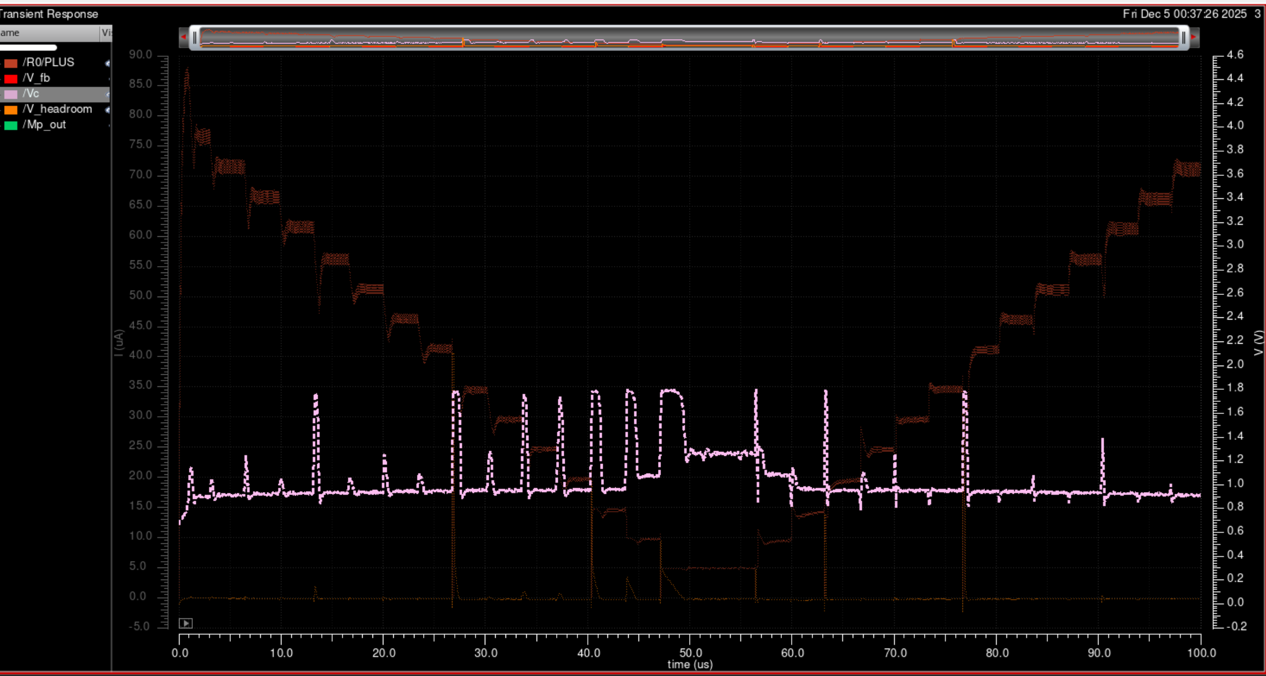
Hugh step test with corner sweep:

The Efficiency of the whole system(considering headroom power and Mp power) is below
Much, much higher than before.
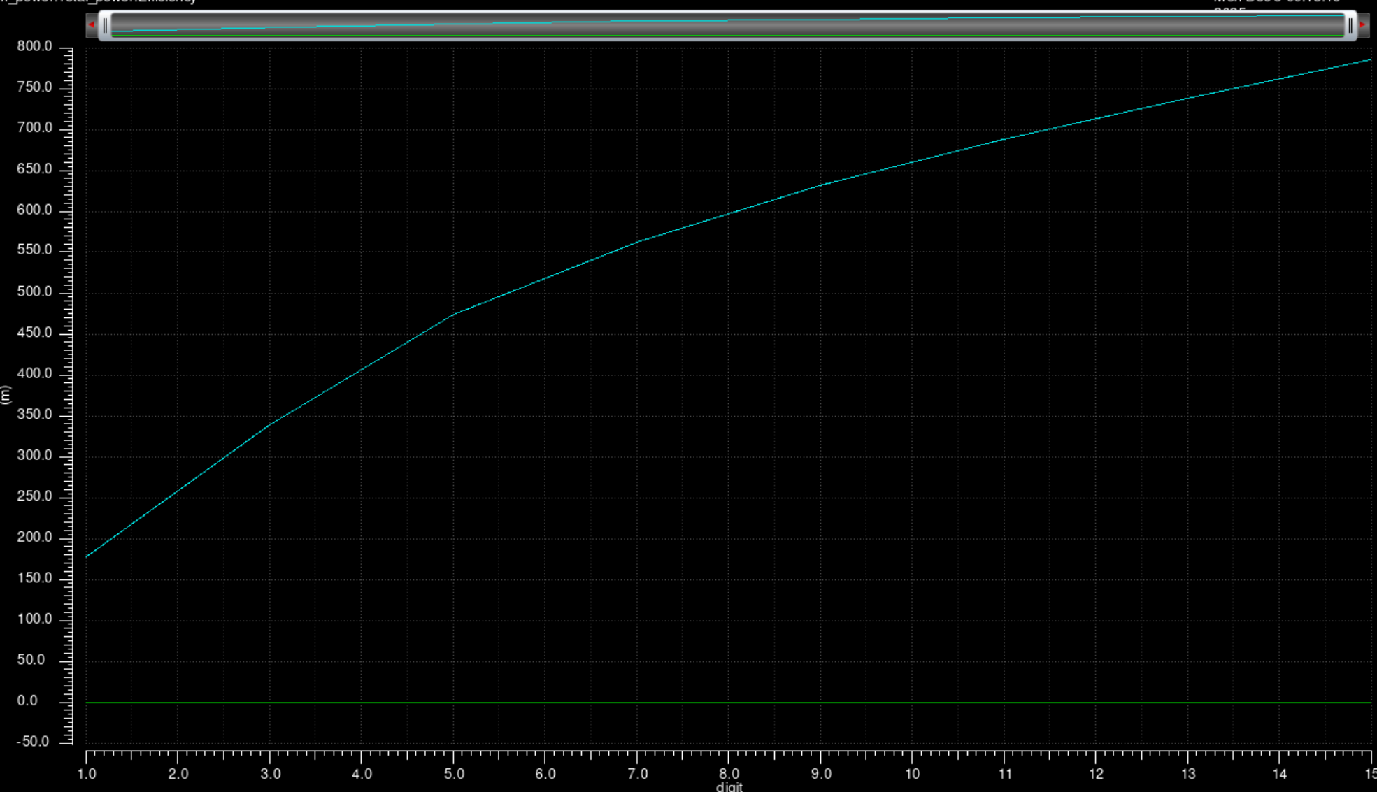
But not higher than I expected because of delay of comparator

